***Bias Variance Trade-Off***

1. *Bias*
2. *Variance*
3. *Overfitting*
4. *Underfitting*
5. *Trade off*
6. *Bias Variance Decomposition*

***The Hidden Truth***

*ML mai 1 hidden truth hota hai, jo kisko pata nahi hota bht kammlog ko pata hota hai,*

***E.g***

*CGPA | Iq|LPA*

*100 student ka data hai.*

*ML Model banana hai jo Sample data dekhke Population ka Prediction krna hai.*

*Yeah 100 bacho se Universal chiz banana hai jo harp bache keliye*

*Prediction bataye.*

***2 type ke error hote hai***

*Irreducible error ka kch nahi krskte*

*Reducible error ko kamm karsakte.*

*Reducible Error = Bias^2 + variance.*

***Bias- Variance-Tradeoff***

***Bias:***

*The inability of a Machine Learning model to fit training data.*

***Variance:***

*Ek ML Model ka Prediction kitna change hota hai When training data is changed that is variance.*

The difference between the error rate of training data and testing data is called variance

***High Bias:***

*Jo ML Model training data pe achese Fit nahi hota usko High Bias Model bolte hai*

*At Same time we say it is Low Vairance*

***Low Bias:***

*Jo ML Model training data pe achese fit hojata hai ushe Low Bias Model bolte hai.*

***E.g of High Bias***

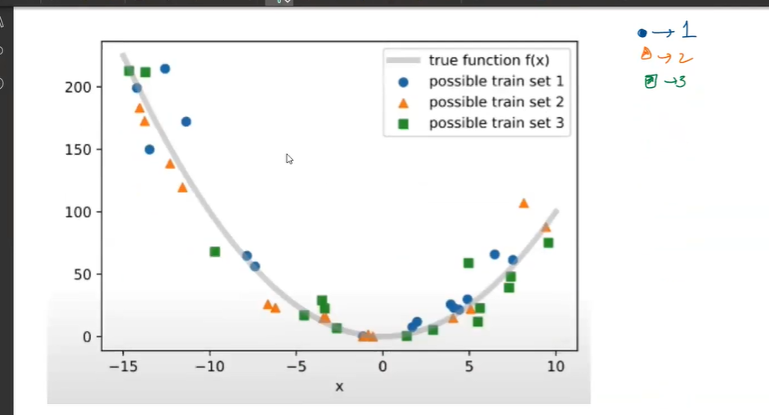

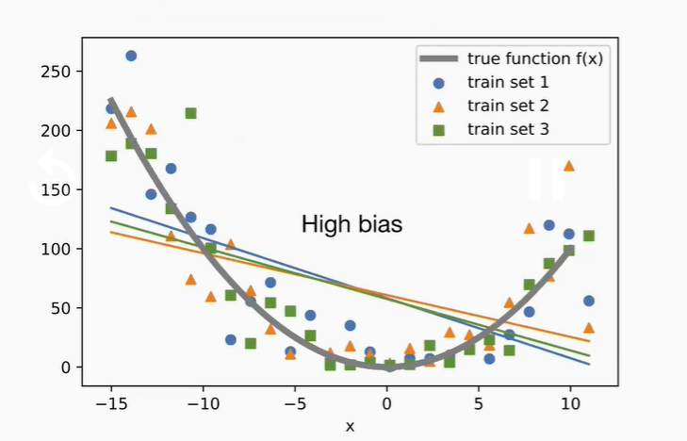

***High Variance***

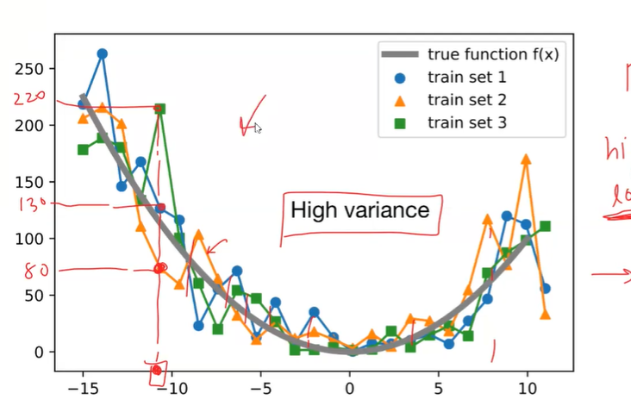

***Low Bias High Variance E.g***



*Low Bias & High Vairance vale most of the time Overfitting hojata hai.*

***Overfitting***

*Training Data pe Acha Result deta hai & Unseen data pe Kharabh result dete hai*

*Ese Models ko Overfit bolte hai hum.*

[Overfitting](https://www.baeldung.com/cs/learning-curve-ml#2-high-varianceoverfitting) happens when we train a machine learning model too much tuned to the training set. As a result, the model learns the training data too well, but it can’t generate good predictions for unseen data. **An overfitted model produces low accuracy results for data points unseen in training, hence, leads to non-optimal decisions.**

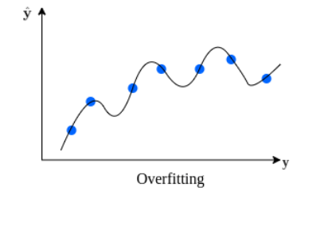

***Underfitting***

*Jo High Bias & Low variance hote they are more likely to be underfitting.*

[Underfitting](https://www.baeldung.com/cs/learning-curve-ml#1-high-biasunderfitting) occurs when the machine learning model is not well-tuned to the training set. The resulting model is not capturing the relationship between input and output well enough. Therefore, it doesn’t produce accurate predictions, even for the training dataset. **Resultingly, an underfitted model generates poor results that lead to high-error decisions, like an overfitted model.**

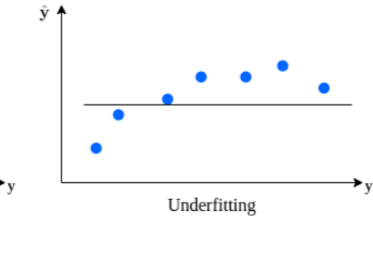

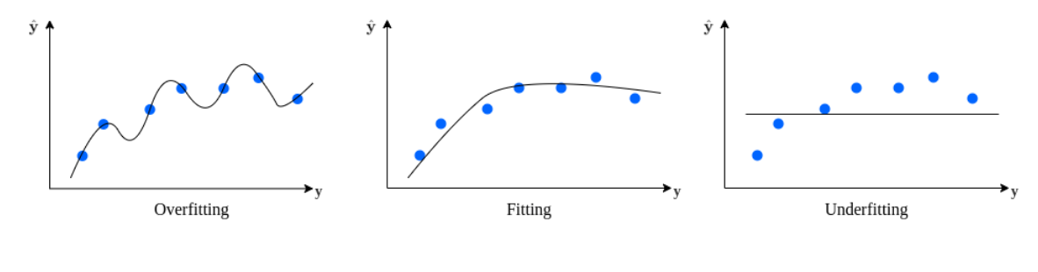

**Reducing the error from overfitting or underfitting is referred to as the**[**bias-variance tradeoff**](https://www.baeldung.com/cs/epoch-neural-networks#neural-network-training-convergence)**. We aim to find a good fitting model in between.**

***The cause for overfitting is a misinterpretation of training data.****So, the model produces less accurate results for unseen data. However, an overfitted model generates very high accuracy scores during the training phase.*

***Similarly, underfitted models don’t effectively capture the relationship between the input and output data because it is too simple.****As a result, the underfitted model performs poorly, even with the training data.*

***Ideally kya chaye***

***Low Bias & Low variance***

*Training Data pe acha Result aarha hai & Dusre data pebhi acha result chaye*

*Yeah Dono sathmai possible hie nahi hota hai.*

*Vairance ko jaise reduce krte hai tou Bias badhjaata hai*

*Bias ko reduce krne jaate hai tou Variance badhjaata hai*

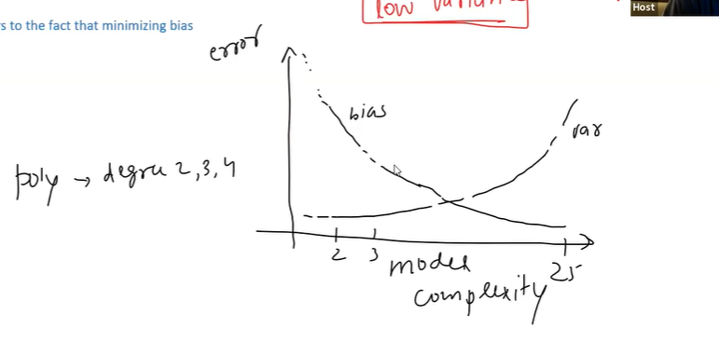

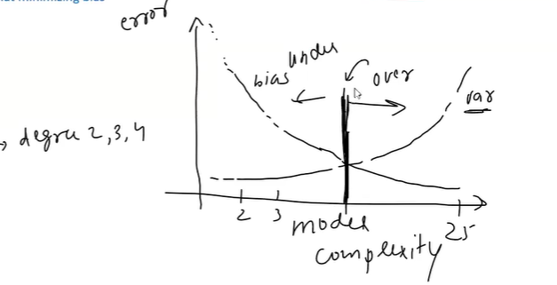

***Expected Value***

